

To: General Purposes Licensing Committee

Date: 15 June 2011 Item No:

Report of: Head of Environmental Development

Title of Report: Pavement Stall Size

Summary and Recommendations

Purpose of report: Proposals for the design, layout and size of street trading pitches, with special reference to pitches that have the capability to overhang the 2m x 1m curtilage.

Report Approved by:

Finance: Paul Swaffield (Approved)
Legal: Daniel Smith (Approved)

Policy Framework: Vibrant, sustainable economy

Recommendations:
Committee is recommended to:
(a) resolve to grant delegated authority to the Head of Environmental Development to decide and authorise variations to stall sizes where it is reasonable and appropriate to do so, having regard to the location of the stall and the type of goods to be sold, up to a maximum size of 2.4m x 1.3m (8ft x 4ft).
(b) agree the prescriptive criteria for a street trading stall as set out in Appendix III, and
(c) resolve to only require the Head of Environmental Development to refer the decision to the Committee for approval if representations are received from interested parties that a stall should not be increased in size or the conditions varied.

Background

- On the 29th March 2011 Licensing & Registration Sub Committee received a report to determine the renewal of a Street Trading Consent to Mr John Irvin trading at the top of St Ebbes Street (site 28). Mr Irvin was in breach of the new conditions (Appendix I) because of the over occupation of the pitch by the use of freestanding displays and storage crates. Following discussion about pitch size and the appearance of stalls in general, Sub-Committee resolved to “ask officers to prepare a report containing proposals for the design, layout and size of street trading pitches, with special reference to pitches that had the capability to overhang the 2m x 1m curtilage, for the next meeting of the General Purposes Licensing Committee”.

.Current situation

- Vehicles are individually approved and Street Trading Consents are specific to the unit concerned. Any changes to or replacement of the vehicle must be approved by the Head of Environmental Development. Trailers are treated as vehicles for the purposes of Street Trading Consents. Under the Street Trading Policy, adopted in 2010, stalls are restricted to 2m x 1m.

- Since the implementation of the Street Trading Policy it has become evident that the current restriction on pavement stall size is proving difficult to meet for some traders. There appears to be an industry standard size; manufacturers have production runs of stalls sized 2.4 m x 1.3 m (8ft x 4ft). It is less expensive for traders to purchase a standard sized stall than have a 2 x 1m stall made to special order.

- On examination it is clear that each stall is different in nature and it appears the permitted size of the stall may be too restrictive. In some cases a stall larger than 2m x 1m would be acceptable having regard to the location and the type of product being sold.

- Some traders, especially those who sell jewellery, can easily manage to meet the 2m x 1m requirement as jewellery doesn’t use much space. Those traders who sell bulkier items such as flowers depend on a slightly larger display. They state there is real commercial need to create a visual impact to attract customers to their display which in turn enhances the local environment.

- It seems reasonable that a stall should have a degree of overhang to form a shelter from inclement weather but this should not be excessive. No articles for sale should protrude beyond the overhang and any display fixtures under this overhang need to be fixed securely to the stall structure to prevent expansion beyond the agreed pitch and for the safety of passers-by.

- Containers of stock must be stored within the footprint of the agreed pitch and no articles should be placed on display above the 2.3m height restriction.

Design

- The current criteria for a stall is open to interpretation (see photographs in Appendix II). In order to raise the standard of stalls it would be helpful to have a more prescriptive criteria (see Appendix III).

Financial Implications

- There is potential adverse risk to future street trading income levels if the stall size dimensions result in traders deciding not to continue trading.

Legal Implications

- There are no legal implications within the content of this report.

Recommendations

- Committee is recommended to:

(a) resolve to grant delegated authority to the Head of Environmental Development to decide and authorise variations to stall sizes where it is reasonable and appropriate to do so, up to a maximum size of 2.4m x 1.3m (8ft x 4ft),

(b) agree the prescriptive criteria for a street trading stall as set out in Appendix III, and

(c) resolve to only require the Head of Environmental Development to refer the decision to the Committee for approval if representations are received from interested parties that a stall should not be increased in size or the conditions varied.

Name and contact details of author:

Dawn Cox
dcox@oxford.gov.uk
01865 252887

Background papers:

Version number: 1

General Conditions for Annual Street Trading Consents

- No trading to which the attached consent relates shall take place except between the dates of:
- The operational hours shall be:
Between the hours of …… and …….. on Mondays
Between the hours of …… and …….. on Tuesdays
Between the hours of …… and …….. on Wednesdays
Between the hours of …… and …….. on Thursdays
Between the hours of …… and …….. on Fridays
Between the hours of …… and …….. on Saturdays
Between the hours of …… and …….. on Sundays
- The street trading consent relates to the following area/site only:
- The street trading consent relates to the following vehicle/stall only:
- Street trading can only be carried out from the stall or vehicle authorised under the conditions of the consent. Any changes to or replacement of the stall or vehicle must be approved by the Head of Environmental Development.
- The Consent Holder shall comply with all statutes, statutory instruments and byelaws currently in force. Consent Holders must pay particular attention to the requirements of the Health & Safety at Work Act, 1974, the Food Safety (General Food Hygiene) Regulations 1995. Advice on these requirements is available from the Environmental Health Department. The Consent Holder shall not drive or park a vehicle on any part of a footway. (It is an offence to drive other than on a road)
- The Consent Holder shall not be the cause of any nuisance or annoyance to any other user of the highway, the occupier of any land or building or the Oxford City Council. Consent Holders shall have special regard to and must take positive action to prevent excessive noise.
- The Environmental Protection Act 1990 places a duty of care on businesses to dispose of waste originating from their trade in a certain manner. The Consent holder shall ensure refuse originating from their trade is disposed of by a licensed waste carrier and shall leave the site clear of refuse at the completion of trading. No water or waste material shall be discharged on to the highway or any adjacent property. The Consent Holder shall ensure that the area in the vicinity of the stall/vehicle is kept clear of all refuse at all times.
- Consent Holder's vehicle/stall shall be kept in a clean, safe and well maintained condition and be of a presentable appearance. The Street Trading Consent bearing the name of the consent holder shall be displayed conspicuously on the stall/vehicle so that members of the public can clearly see it during hours of business.
- The Consent Holder's vehicle shall be maintained in a roadworthy condition, taxed, insured and with a current MOT Certificate.
- The Consent Holder shall ensure that the stall/vehicle is positioned only in the allocated space (which may be marked on the ground) in the Consent Street for which the Street Trading Consent is issued. All goods shall be displayed on the stall and no freestanding racks or displays are permitted. If a Consent Holder or operator/assistant is requested to move the vehicle/stall by an authorised Council Officer or Police Officer they shall immediately comply with that request.
- The Consent Holder's stall shall not exceed 2.3 metres in height nor occupy an area greater than 2 metres x 1 metre.
- The Consent Holder must take adequate precautions to prevent the risk of fire at the stall or vehicle. All hot food vans/trailers are required to comply with current legislation on fire safety. Where gas cylinders are used an annual gas safety certificate is required to ensure the safety of all gas cooking and heating equipment. A serviceable fire blanket and a foam fire extinguisher shall be provided in all vehicles selling hot food.
- All hot food vans/trailers are required to carry a basic first aid kit. The Consent Holder and others operators should know how to give first aid to treat victims of burns and cuts. All hot food vans should have access to a minimum of one mobile phone that must be serviceable at all times.
- All staff involved in the preparation of food shall hold a current Level 2 food safety certificate, that is accredited by the Chartered Institute of Environmental Health, or the Royal Society of Health, or the Royal institute of Public Health and Hygiene.
- A Street Trading Consent cannot be transferred or sold to another person except that the Consent may be transferred to a member of the Consent Holder’s immediate family in the event of the Consent Holder’s death or incapacity on payment of a fee. The sub letting of a pitch is prohibited.
- The Consent Holder must be the principal operator and have day to day control of the stall/vehicle. The Consent Holder may employ any other person to assist in operating the stall/vehicle and shall notify the Head of Environmental Development of the name and address of that person. An administration fee will be payable.
- Anyone who operates a stall/vehicle other than the Consent Holder must be authorised by the Head of Environmental Development.
- A Consent Holder may terminate a Street Trading Consent by written notice to the Head of Environmental Development. A refund of the portion of the fee equal to the remaining full months will be payable, less £50 which the Council will retain to cover administrative costs.
- Consent holders shall ensure that disabled people and wheelchair users can be adequately served. This may involve serving persons from outside the vehicle.
- A copy of the Consent shall be carried by the operator when trading and must be produced on demand to a Council Officer or Police Officer.
- Consent Holders shall have and maintain a proper insurance policy against public liability and third party risks. The minimum insurance cover shall be £10,000,000 and shall cover the operator's vehicle, or stall and any additional equipment under their control. If food is sold the insurance shall specifically include cover against food poisoning to the same amount. The insurance certificate or cover note shall be produced to the City Environmental Health Officer before the Street Trading Consent is issued. Proof of cover must be produced to an officer of Oxford City Council as required.
- These general conditions, which apply to all Street Trading in Oxford, may be varied, having regard to a particular location. They are termed Special Conditions and listed on the Consent Certificate. These Special Conditions must also be complied with.
- Instalments are required quarterly, in advance. On or before the following dates 1st April, 1st July. 1st October and 2nd January. Annual fees may be paid in advance.

Failure to comply with these conditions
If a Consent Holder fails to comply with any of the conditions attached to a Street Trading Consent, the Consent may be suspended for an indefinite period or revoked. The Consent Holder may also be prosecuted.

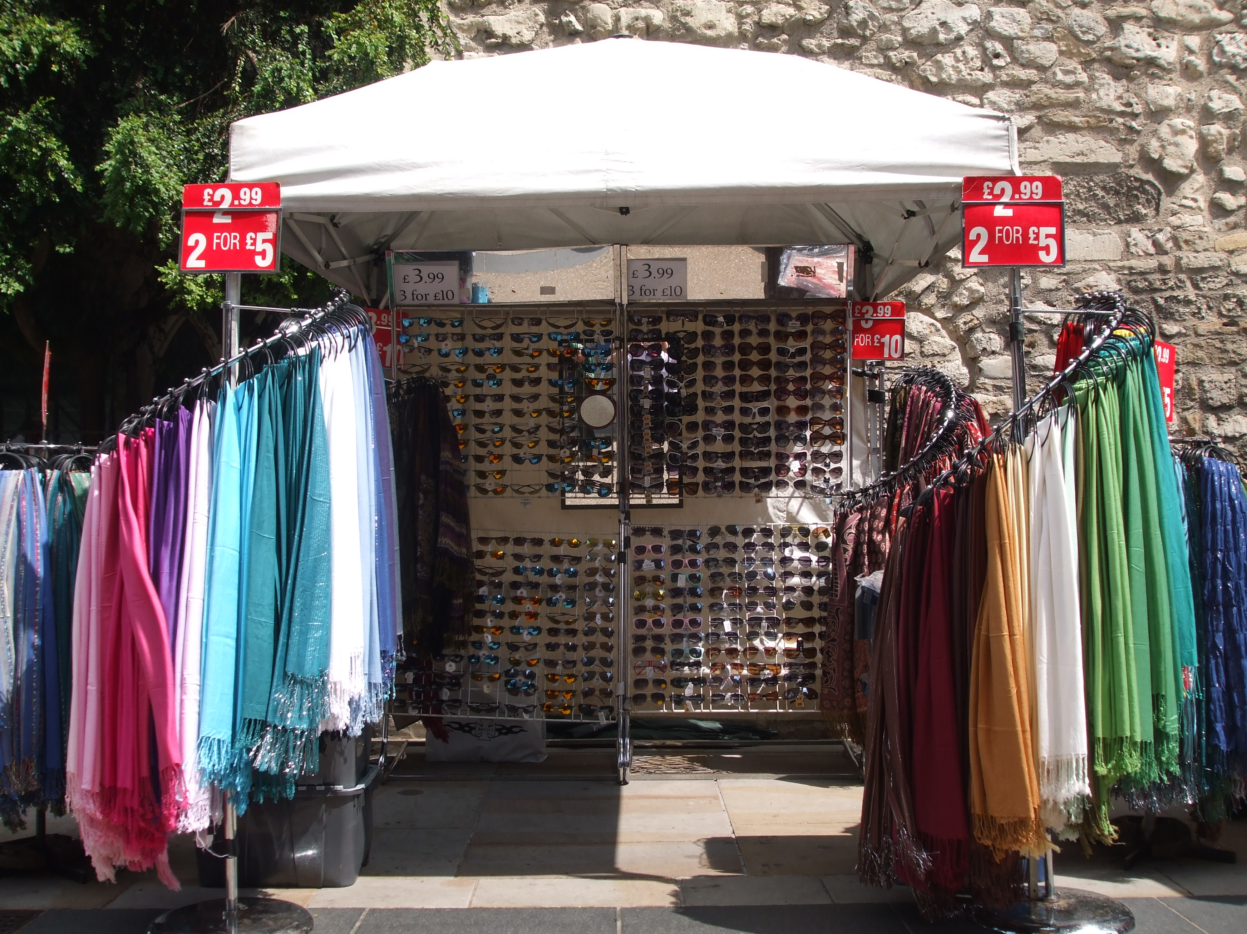

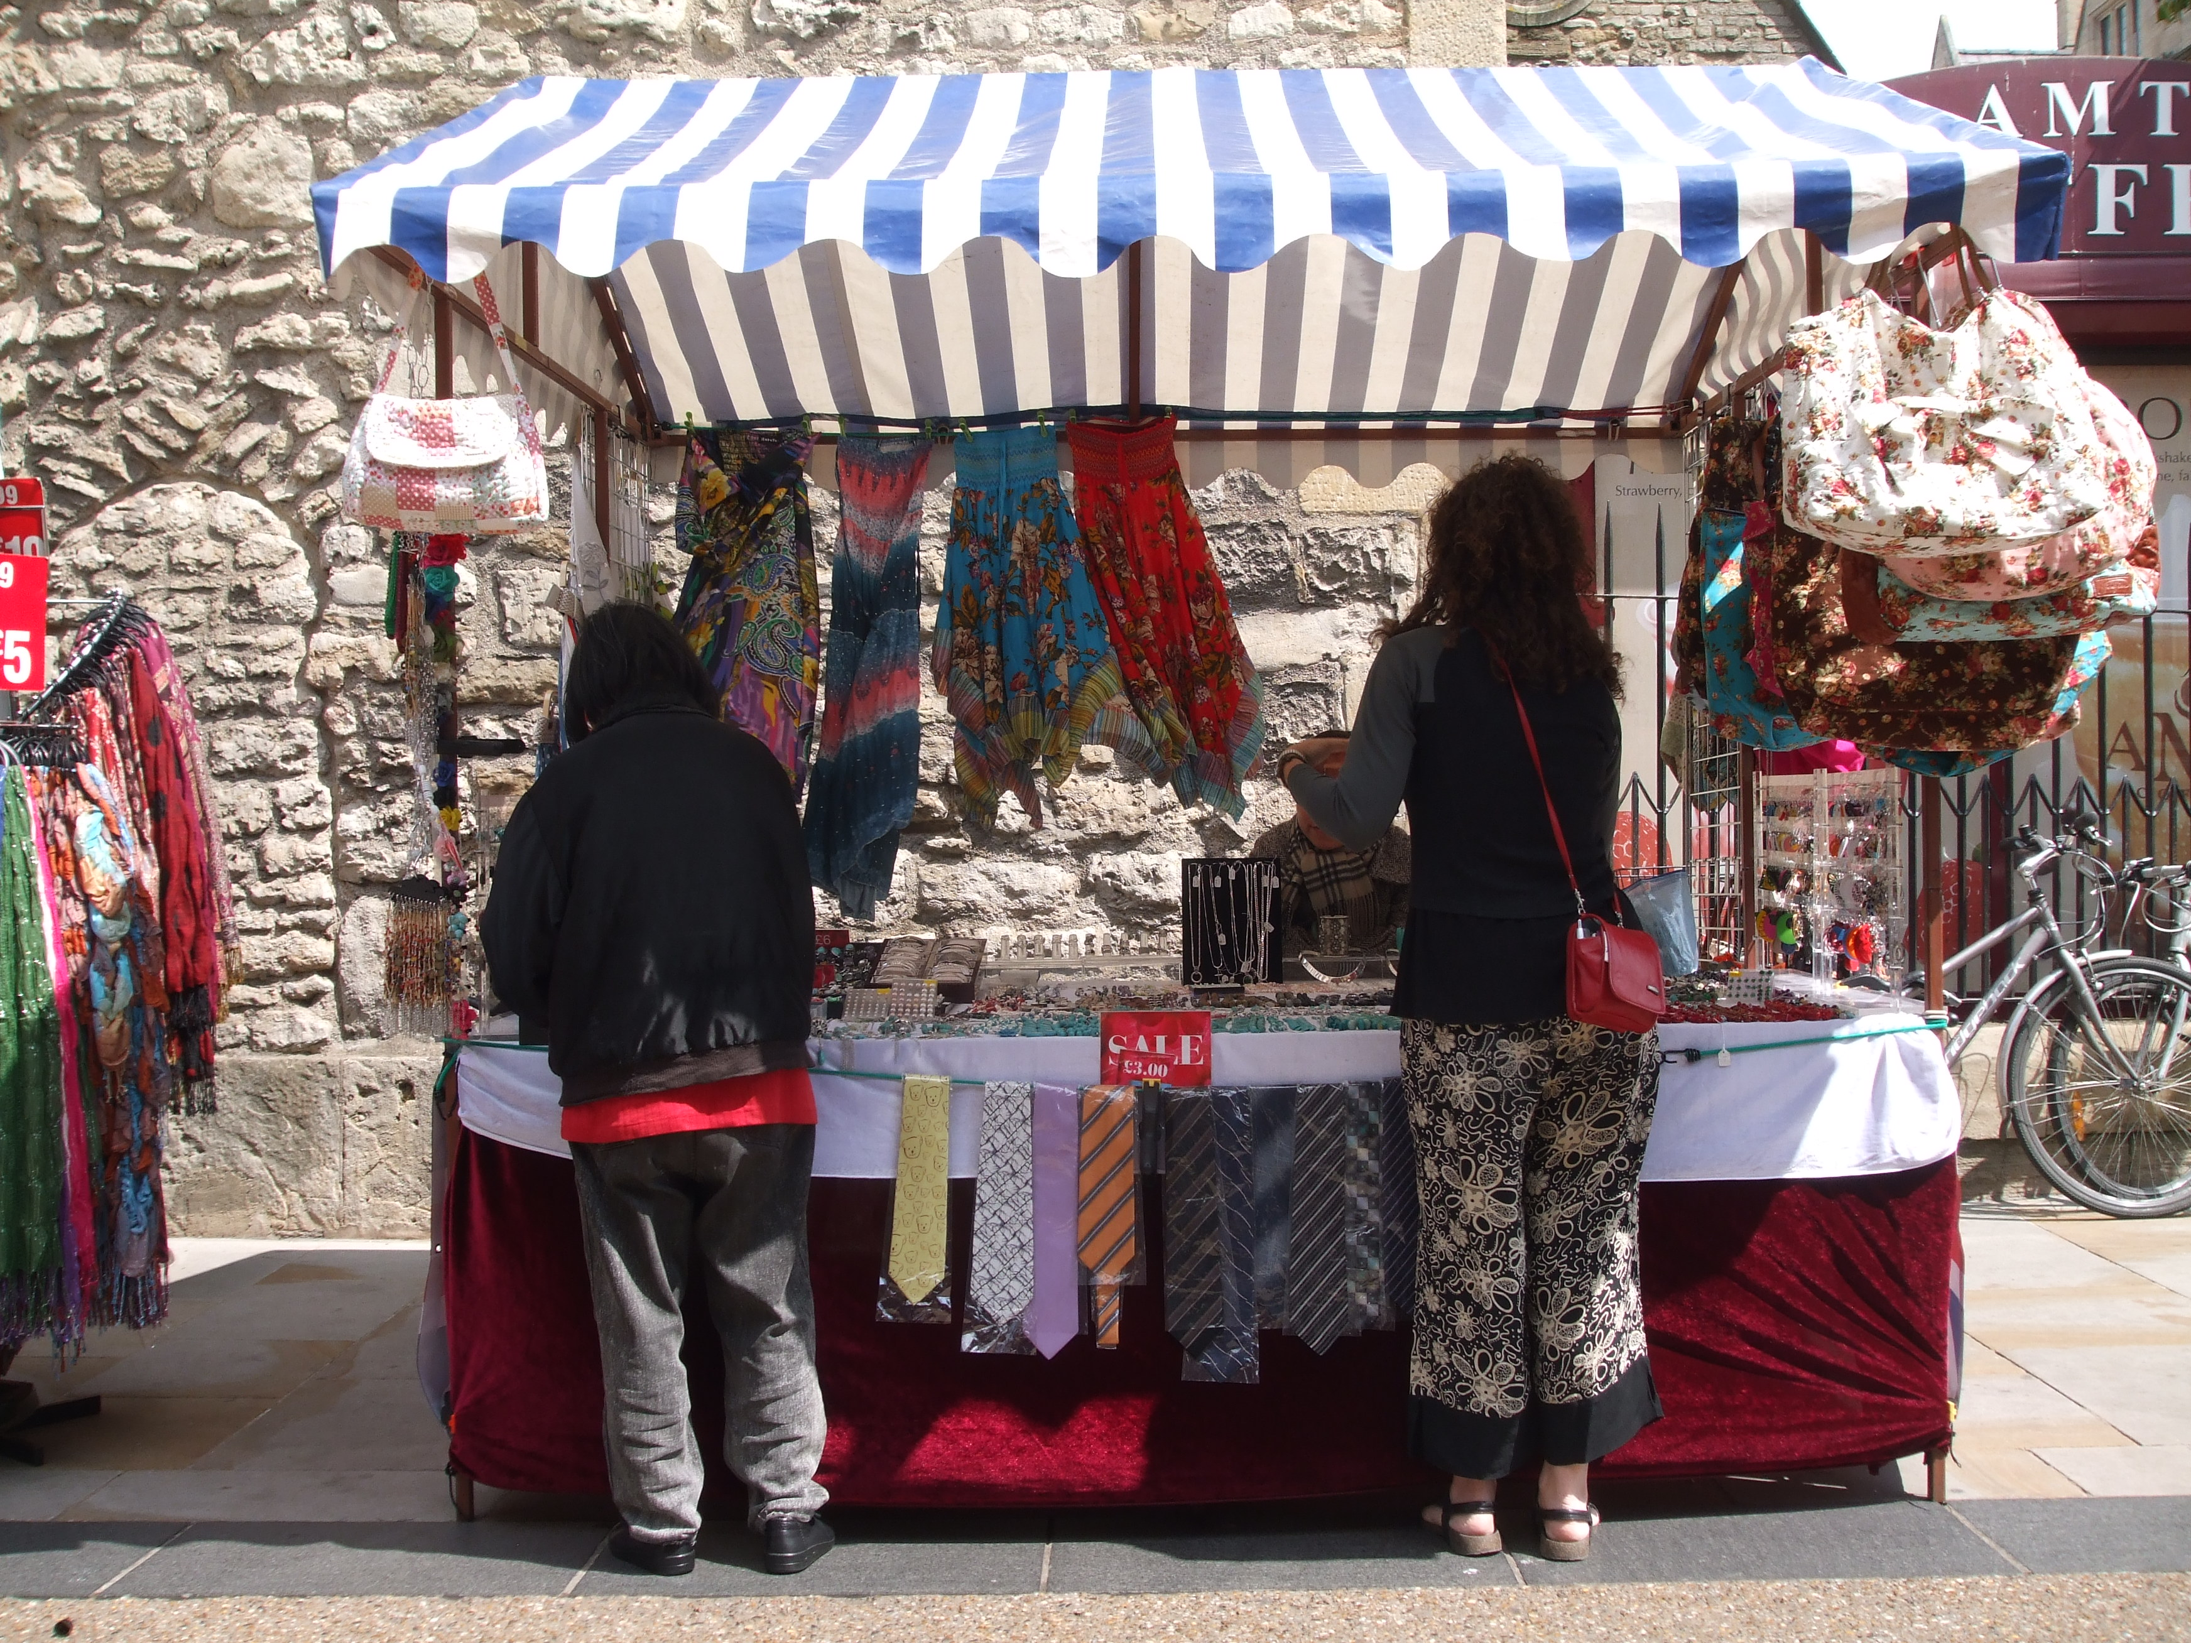
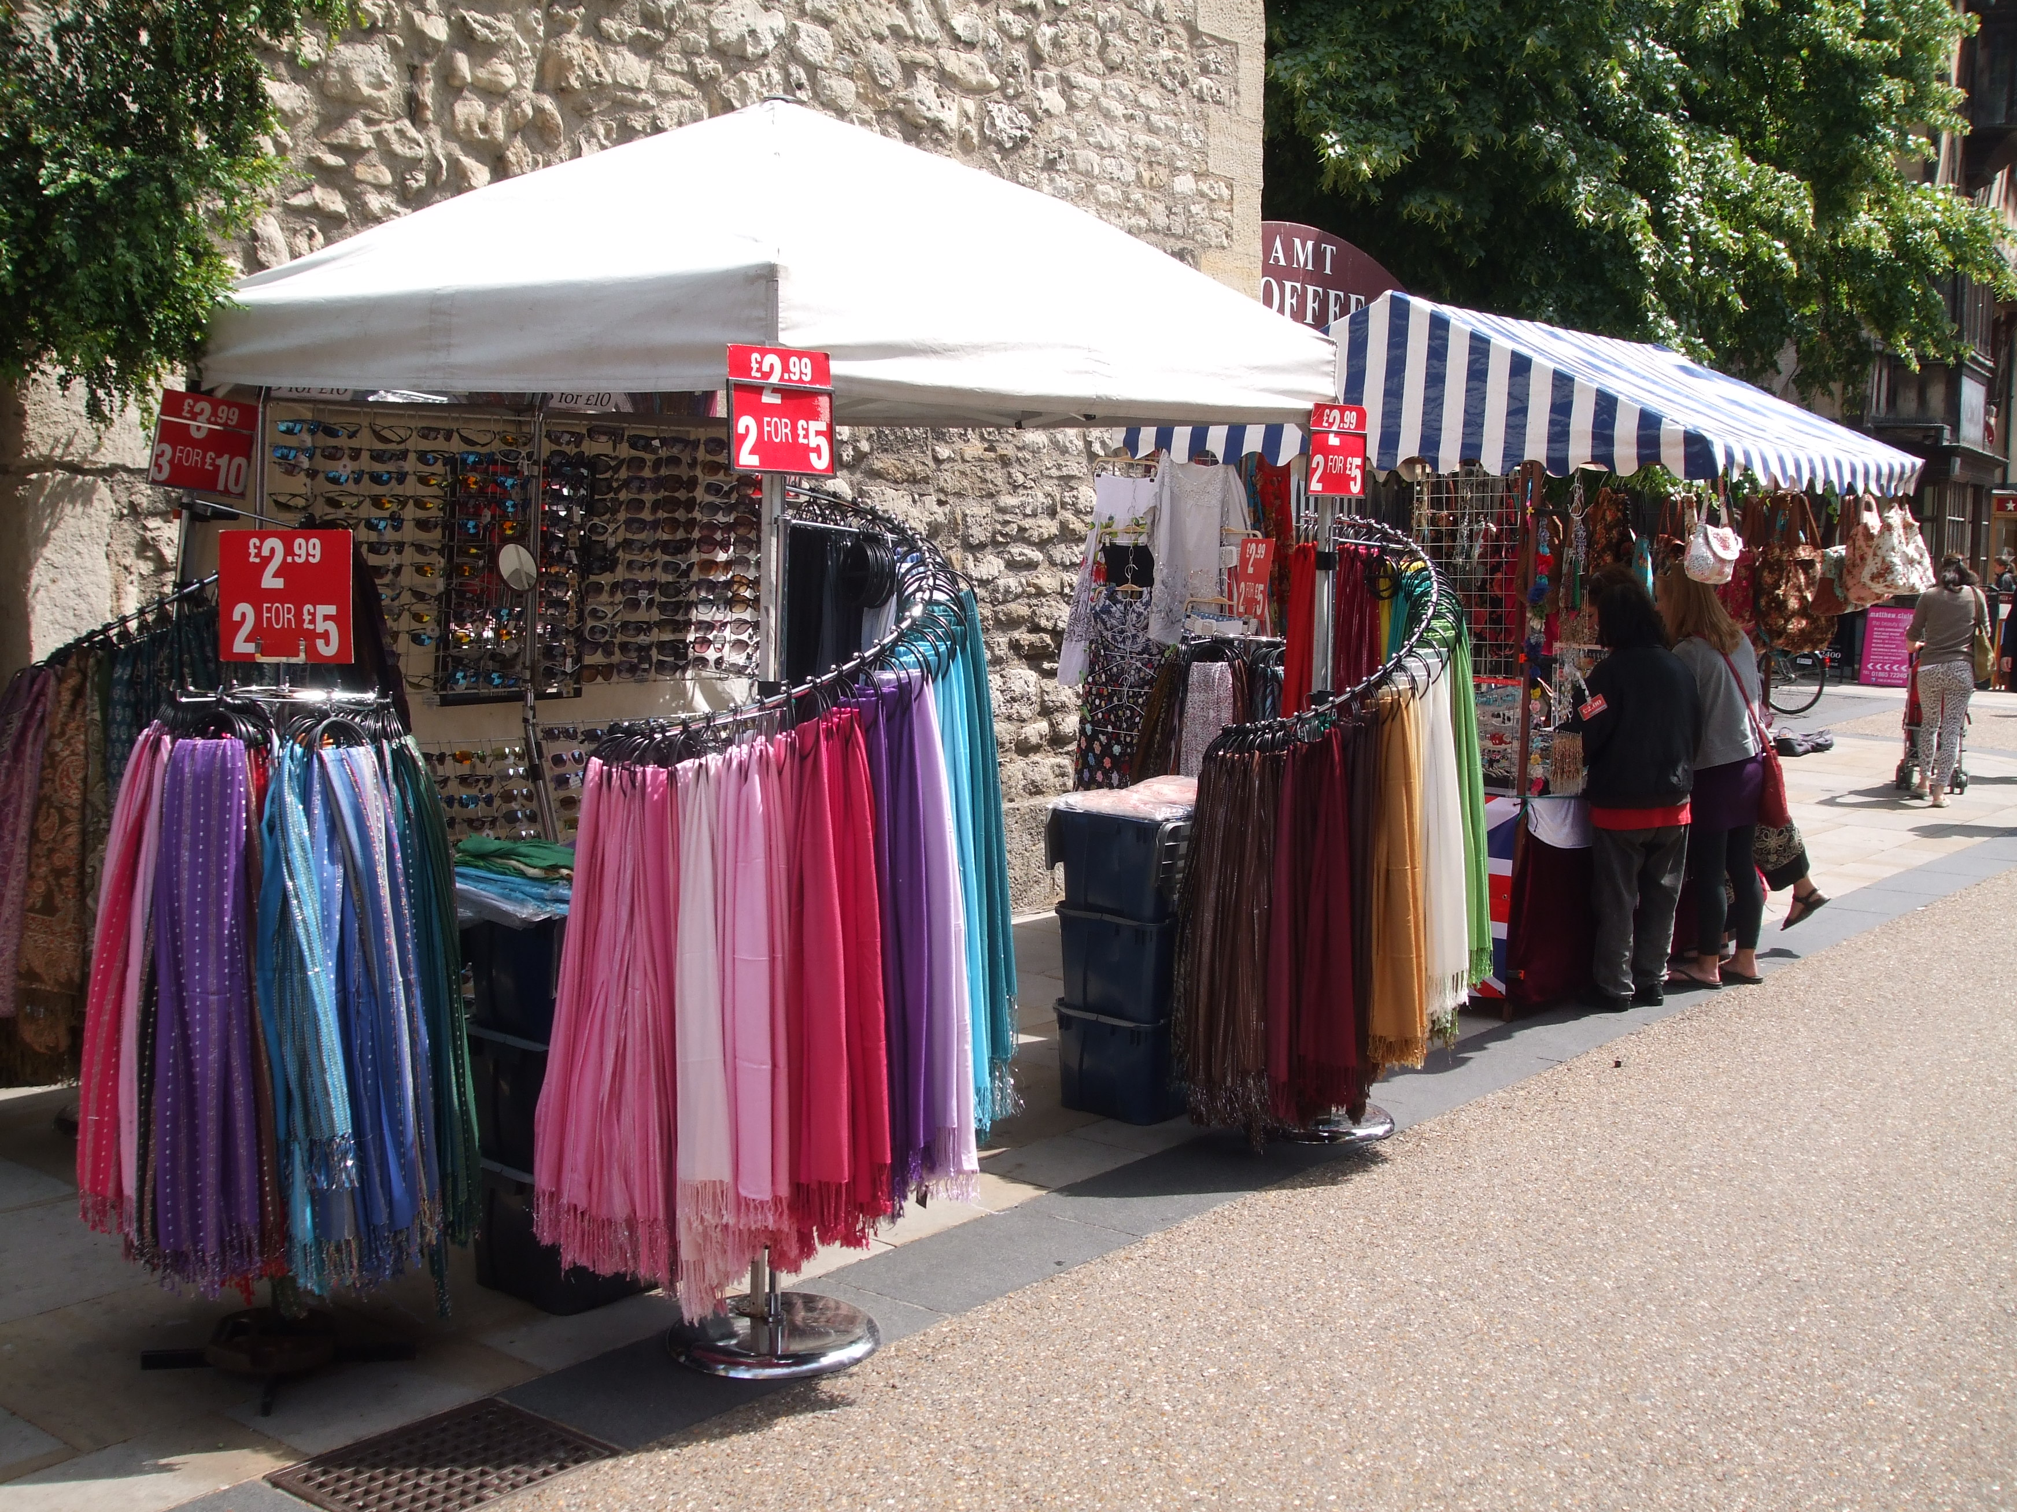

Criteria for a Street Trading Stall in Oxford City

A traditional market style stall:

- The stall must be purpose built.

- The stall must be portable i.e. brought to site and erected every day.

- The stall must have a steel or wooden frame.

- The stall must have an overhanging apex roof with top cover in Oxford Blue livery.

- The stall may have a matching skirt around the front edge of the display.

- The stall must incorporate a table for the display of goods.

- The stall dimensions shall not exceed 2.3 metres in height nor have a footprint of greater than 2.4m x 1.3m (8ft x 4ft).

